Education Round
Information booklet
Version 2.0
57th and 58th board of C.T.S.G. Alembic
Revised on the 25th of August 2021

Kick-In 2021
Chemical Science and Engineering

Content
1. Introduction 1
2. Commissioner of Educational Affairs and student perspective 2
2.1. Introduction 2
2.2. Commissioner of Educational Affairs of the candidate 58th board of C.S.T.G. Alembic 3
2.3. Useful links 3
3. Alembic, study books, printer and KNCV 4
3.1. Alembic 4
3.1.1. How to become a member? 4
3.1.2. How to make an Alembic account? 4
3.1.3. Shares of Alembic 4
3.1.4. Alembic discord server 5
3.2. Study books 5
3.2.1. Studystore 5
3.2.2. UnionShop 6
3.3. Printer 6
3.4. KNCV 6
4. Program staff 7
4.1. Introduction 7
4.2. André ten Elshof 7
4.3. Nienke Oesterholt 8
4.4. Pepe Veugelers 8
4.5. BOZ employee 9
4.6. Leonie Krab 9
4.7. Charlotte Diepenmaat 9
5. Useful computer programs and websites 10
5.1. General 10
5.2. Eduroam 10
5.3. EduVPN 13
5.4. Osiris 15
5.5. Osiris Catalogue 15
5.6. MyTimetable 16
5.7. Campus app 17
5.8. Canvas 17
5.9. Resource Booker 17
5.10. Software Manager of NSC 18
5.10. Lean Library Plug-in 18
6. Online education 19
6.1. Introduction 19
6.2. BigBlueButton 19
6.3. BlueJeans 20

1. Introduction
This booklet will explain the necessary information that is needed to start studying Chemical Science and Engineering. The document will be divided into 5 sections:
- Commissioner of Educational Affairs and studying from a student’s perspective
- Alembic, Study books and KNCV
- Program staff
- Useful computer programs and websites
- Offline university
Almost all these sections are set up in a way that you can follow the steps by yourself. If assistance is needed, ask one of the do-group parents, KIKSTart members, or (candidate) board members. In the text, buttons and references to specific pieces of text will be written in ‘italic’, and text that needs to be filled in is printed in ‘bold’. For questions mail to education@alembic.utwente.nl. For more information visit the website of the university via this link.

2. Commissioner of Educational Affairs and student perspective

2.1. Introduction
Within this part, the Commissioner of Educational Affairs of the candidate 58th board of C.T.S.G. Alembic will be introduced, and a student will be explaining how it is to study at the University of Twente.

2.2. Commissioner of Educational Affairs of the candidate 58th board of C.S.T.G. Alembic
Dear kiddo,

My name is Jochem Schuerman. You may already have heard from me because I’m also the treasurer of KIKSTart 2021. The positions I will be holding the next academic year are the Secretary and the Commissioner of Educational Affairs. I will be part of the 58th board of C.T.S.G. Alembic. With four other people we will lead the study association C.T.S.G. Alembic.

The function of Commissioner of Educational Affairs has to do everything with the educational part of the study association. I will be in close contact with the program staff and will try to improve the study experience of your first year. If you have a question regarding the study or other educational parts of the university and the study association, feel free to contact me by mail, WhatsApp or just at the Alembic rooms in Carré. Questions about a different topic can be asked as well, and I will try to help you in the best way I can.

Jochem Schuerman
Secretary & Commissioner of Educational Affairs
Candidate 58th Board of C.T.S.G. Alembic
“De Glorie van Twente!”

© Jochem Schuerman, 58th board of C.T.S.G. Alembic
© Jarno Sweers, 57th board of C.T.S.G. Alembic

2.3. Useful links
To start, here are already some practical websites with information about the TOM education, Dutch education system, grading system and Tips and Tricks for internationals:
TOM education | www.utwente.nl/en/tom/whatistom/
Dutch education style | www.utwente.nl/en/education/bachelor/study-in-holland/academic-culture/
Grading system: | www.utwente.nl/en/education/bachelor/study-in-holland/grading-system/
Tips and Tricks internationals: | www.studyinholland.nl/life-in-holland  www.utwente.nl/en/education/student-services/int-files/international-student-handbook.pdf
Dutch/UT Holidays: | https://www.utwente.nl/en/ces/planning-schedules/academic-calendar/

3. Alembic, study books, printer and KNCV

3.1. Alembic
C.T.S.G. Alembic is the study association for the bachelor and master Chemical Science and Engineering. It is an abbreviation for Chemotechnisch Studentengenootschap Alembic. The study association organises fun activities with their committees related to social and educational aspects, such as study nights to study for upcoming exams or lunch lectures for broadening knowledge about different companies. Next to this, you can meet the other students of the study programme, these can be from your own year or from other years of the bachelor or master. Another benefit is a discount on your study books of about 19% and you can pick up notebooks for free in the boardroom. For additional information visit the website of Alembic at www.alembic.utwente.nl.

3.1.1. How to become a member?
If you want to become a member of Alembic, please ask any board member or send an email to secretary@alembic.utwente.nl.

3.1.2. How to make an Alembic account?
This has to be done at a computer of Alembic. When you are available during the start of the academic year, you need to visit the boardroom of Alembic at room CR3029. Here a board member assists you in setting up an Alembic account. To make an account fill in your username. This username starts with ‘ALEMBIC\’ followed by your first name and surname in lower case without spaces between it. Next to this you need a password for your account but use at first ‘alembic123’. Press on ‘Enter’ and fill in your new password. If this is not yet possible, the board will announce an alternative way of getting an Alembic account.

3.1.3. Shares of Alembic
On the shares of Alembic, documents are stored which are important for members of Alembic. These documents consist of old test exams, photos of activities held by Alembic and many important documents for example information about the General Members Assembly (GMA) or information about making a poster if you join a committee.

If you are connected to eduroam (Eduroam is the Wi-Fi network of the Campus. How to connect to eduroam? Click here), you can also connect to the shares of Alembic with an VPN connection (How to install OpenVPN? Click here). Press ‘Windows Key’ + ‘R’, this opens the ‘Windows Execute’ program. Here you can fill in the following execution code, ‘\\ethanol.alembic.utwente.nl’.

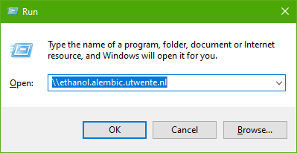

After this a login window will pop-up. Fill in your username and password that are set-up for your Alembic account.
Username: ALEMBIC\first name surname
Password: Alembic password

3.1.4. Alembic discord server
Alembic has a discord server that can be used to socialize with other members of Alembic. Besides socializing, it is also a place where you can study with other people of the CSE community. The invite link is www.discord.gg/VDTHCve. Give yourself a recognizable name and ask a board member to approve you.

3.2. Study books

3.2.1. Studystore
To order the books for the first module can the following site be used, alembic.itdepartment.nl/en. For the first module the chosen selection depicted in the figure down below can be used. For future modules a mail will be sent when the books can be ordered.

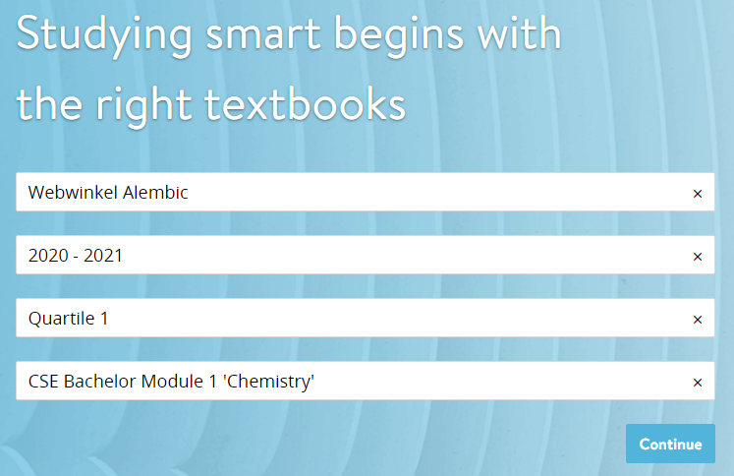

When filled in correctly, click on the button that says ‘Continue’. You will be redirected to the page with the books that you need to order for the module. At the top you will find three options. These options are given below. Select the option that holds for you.

Within each box of a book that can be ordered, a message will be shown. These messages can be ‘compulsory’, ‘Recommended’ and ‘Possible already in possession’. With this list you need to select all three books and click on ‘Add’.

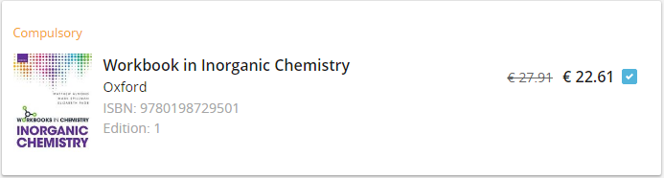

Next, you need to register at LearnID. Click on ‘Register’ and fill in the form for ‘Create new account’. After this you can fill in your information details at the step ‘My information’. Click on ‘next’ and select on this page (‘Delivery and payment’) the correct settings for yourself. If you don’t have a Dutch bank account yet, you can contact someone from the board for assistance. At the last step ‘Check’, you need to check the box for ‘I agree with the Terms and Conditions and understand that I am entering into a payment obligation.’ and select the ‘complete order’ button.

3.2.2. UnionShop
During some of the modules you need a reader for a subject instead of a book. For instance, the first module has three additional readers. The first one is the ‘General Laboratory Manual’, the second one is ‘Introduction to Mathematics’ and the third one is ‘MATLAB Instructions Chemical Science and Engineering’. The costs for these readers are at most €10,- per piece. The correct copy of these readers will be announced during the first lectures of the subject. These books can be bought at the UnionShop at the university. Next to readers you will need labjournals for practicals that can be bought here. Labjournals are notebooks in which you make notations in advance and during the practicals. The labjournals are also available in the boardroom of Alembic. The UnionShop is located at the building called the ‘Bastille’. For more information visit their website at su.utwente.nl/en/unionshop.

3.3. Printer
At the university you can print at certain printers that are labelled as student printers. For these printers you need to register at first. To register, hold your college card to the RFID scanner of the printer. A document with a code will be printed with the further needed instructions. Go to printportal.utwente.nl and enter your student number at ‘Username’ and your corresponding password. Click on ‘Log on’ and continue. When logged in, select the tab ‘Card Registration’ and fill in your obtained code from the printer. Click on ‘Submit’ and your card is successfully registered.

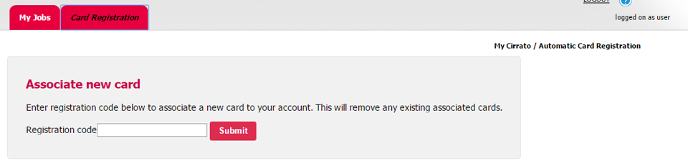

If you want to print something, you scan your college card and print from your USB stick or you send your files to the printer. To print via the last option for Windows 10 goes as follows. Search within the search menu at the bottom left of your screen for ‘\\printservice.utwente.nl\follow-me’. Fill in ‘AD\’ followed by your student number at ‘Username’ and your password at ‘Password’. The driver will be downloaded and when a window with the title ‘Follow-Me on printservice.utwente.nl’ pops up the installation is completed. For example, Word you can now select the Follow-Me option and press on print. The instructions for Mac OS X can be found here.

3.4. KNCV
The KNCV (Koninklijke Nederlandse Chemie Vereniging / Dutch Chemistry Association) Is the national association for Chemistry associated students, professors and employees. The KNCV has a broad network with numerous universities and chemists throughout Europe. Furthermore, they organize numerous informative and networking activities throughout the year, as a member these activities are either free or have a discount.

The first year of membership at the KNCV is for free, so during this year you can fully explore the benefits of the KNCV! Enrol with the following link: en.kncv.nl/studentmember.

4. Program staff

4.1. Introduction
With this round the program staff will be introduced. This section did already occur in the do-group information booklet CSE, but it is included for completeness. Added to this section, there will be a presentation of André ten Elshof about the program.

For the program of Chemical Science and Engineering, a couple of people are important. For example, the program staff, these people can help you during your time of studying at the university. These people are André ten Elshof, Nienke Oesterholt, Pepe Veugelers, Erna Brus, Leonie Krab and Charlotte Diepenmaat. Another group that is very active within the study programme are the lectures and the research clusters. The teachers can be found at Osiris or Canvas and for more information about the research clusters, visit the next website: www.utwente.nl/en/tnw/research. These teachers will maybe be your next mentor. You will also get a peer student from Alembic, which can help you if you come across any problems. For international student there is also a possibility to sign up for a buddy program in which you get acquainted with the study, University and with the Netherlands. For more information about this topic visit the canvas course ‘Programme information CSE/ChE’.

4.2. André ten Elshof
Programme director Chemical Science and Engineering; Professor of Inorganic Nanomaterials Chemistry
My picture is on this page because I am the proud director of the Chemical Science and Engineering programme. But you may also meet me in other capacities: I teach inorganic chemistry and materials science in modules 1 and 3, and chemistry of nanomaterials in the master ChE. And as a scientist, I like to work together with students from CSE and other programmes to develop exciting new materials for our 21st-century society. You can find me on the 3rd floor in Carré within one of my 2 offices: in CR 3017 (as CSE director), which is located very close to the Alembic room and Home Base, or in CR 3249 (as a professor). You can also contact me by email at j.e.tenelshof@utwente.nl. My advice to you for this year: work hard and make friends!

4.3. Nienke Oesterholt
Study Advisor BSc Chemical Science and Engineering
As a study advisor, I am the first contact person for all study-related questions. Together with your mentor, I support you during your bachelor programme. You can talk with me about study or personal problems. Our meetings are confidential.
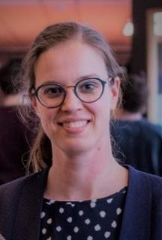
Feel free to make an appointment if you need advice on study planning or information about studying with disabilities. I listen to you, can give advice and if this it’s necessary, I can help you find a suitable form of support at our university.
You are welcome in my office on the 3rd floor in Carré in nearby the Alembic room. You can also contact me by email: n.h.oesterholt@utwente.nl or schedule a meeting in the TNW planner: tnw.planner.utwente.nl. My advice for you: if you can let your thoughts, problems or concerns remain a butterfly, they will never become an elephant.

4.4. Pepe Veugelers
Secretary Board of Examiners Chemical Science and Engineering; Lecturer
You will probably meet me first in my position as a teacher: I am responsible for three first year practicals and teach Thermodynamics in the second module. However, the reason that I am on this page is my position as secretary of the Board of Examiners. The main task of the BoE is ensuring the quality of examinations and final examinations. To this purpose, the BoE has established a set of rules, the “Rules of the Board of Examiners”. From the main task, a number of more detailed tasks have been derived.
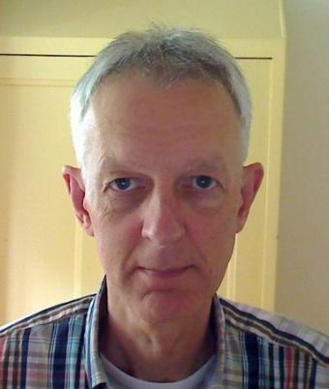
Relevant for you as a student is for example:
- Granting exceptions to the Rules of the BoE
- Granting exemptions for taking examinations
- Impose sanctions for fraud
- Granting permission to start a minor, BSc-assignment or MSc-assignment
- Issuing of certificate and diploma supplement
- Granting the designation ‘with distinction’ (Cum Laude)
For these and other purposes, you can file a request to the BoE, which should be sent to the Educational Affairs Office (boz-cse@utwente.nl). Many of the standard requests will be processed by me, but others have to be treated in the meetings of the BoE, which are approximately once every two months. I hope you enjoy the practicals! For the content and for the opportunity to meet your fellow students. Prepare them well to get the best out of them!

4.5. Erna Brus
Educational Affairs Office
At this moment I am an employee of the Educational Support Office, popularly known as BOZ (Bureau Onderwijszaken). BOZ is responsible for the registration of programs and courses in Osiris. And if you have any questions for the Examination Board you may send this to BOZ. And in the end, when you have finished your bachelor program BOZ will make sure you’ll receive your diploma. You can contact BOZ by email: boz-cse@utwente.nl.
But for me: I’m looking forward to start my new job as a bachelor coordinator CSE on 1 October. So you will most likely meet me in this capacity.

4.6. Leonie Krab
Programme Coordinator BSc Chemical Science and Engineering; Lecturer; Mentor
I coordinate the programme (and modules 11 and 12), which includes among other things making sure that you, at the right time, obtain all relevant information about the programme. If all goes smoothly, you may not see me that often. However, you will certainly meet me in workshops that are aimed at developing your essential skills, like writing an academic text (in proper English), effective teamwork, cooperation in groups with diverse people, problem-solving, critical thinking, etc. My home-base is Carré 3019.
To get the most out of your time with us, I suggest you ask a lot of questions, even if that is outside your comfort zone. Prepare well. If you want to develop yourself, things will not always be easy, yet you need some resistance to grow… Talk to your mentor to discuss your struggles and to get advice – we are all experienced and here to help you on your journey towards your BSc degree. I wish you an educational and joyful study time, amongst new friends!

4.7. Charlotte Diepenmaat
Study Adviser and Programme Coordinator for MSc Chemical Science and Engineering
First of all: welcome (back) on campus! I greatly enjoy the atmosphere on campus and I experience it as very easy-going. That is why, after graduating from UT in 2012, I returned a couple of years later as an employee. I hope you will have the same pleasant experience on campus as I have had as a student.
I have been working at UT for the past three years. First as Communication Officer and currently as Study Adviser and Programme Coordinator for the Master Chemical Science and Engineering.
If you have any questions, study- or non-study related or just want someone to share your thoughts with: feel free to drop by. You can find me in Carré, CR 3015.
My advice for your time at UT is: do your best, ask questions, take well-deserved breaks and above all: enjoy your time as a student.

5. Useful computer programs and websites

5.1. General
For the completeness of this section topics that are already may have been done, will be included as well. The computer programs and websites that will be explained are:

- Eduroam (mobile and computer)
- EduVPN
- Osiris
- Osiris Catalogue
- MyTimetable
- Campus app
- Canvas
- Resource Booker
- Software Manager of NSC
- Lean Library Plug-in

If you have problems with your set credentials for your university account, try to ask for assistance and consider changing your password. To change your password, click here.
For more information please check out this link.
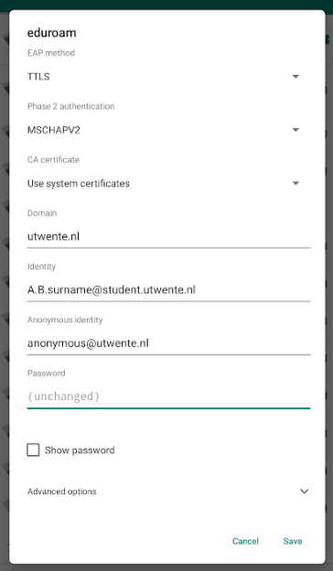

5.2. Eduroam
Mobile (Android):
- Go to ‘Settings’, ‘Wi-Fi’.
- Select ‘eduroam’.
- At ‘EAP method’, select ‘TTLS’.
- Select ‘MSCHAPV2’ at ‘Phase 2 authentication’.
- Select ‘Use system certificates’ at ‘CA certificate’. If this is unavailable, select ‘Do not validate’.
- Fill in ‘utwente.nl’ at ‘Domain’.
- Enter your ‘UT e-mail address’ in the ‘Identity’ field.
- If required fill in ‘anonymous@utwente.nl’ at ‘Anonymous identity’.
- Enter your ‘password’.
- Tap on ‘Connect’.
- You’re now connected with eduroam.

Source: utwente.nl

Mobile (iPhone):
- Go to ‘Settings’, ‘Wi-Fi’.
- Select ‘eduroam’.
- In the first field, enter your ‘UT e-mail address’.
- In the second field enter your ‘password’.
- Click ‘Join’.
- Make sure the ‘Certificates’ server name is ‘radius.utwente.nl’.
- Click ‘Trust’ (top right).
- You’re now connected with eduroam.

Source: utwente.nl

Computer (Windows 10):
- Click the wireless network icon on the taskbar.
- Click ‘eduroam’.
- Check ‘Connect automatically’.
- Click ‘Connect’.
- In the first field, enter your ‘UT e-mail address’.
- In the second field, enter the ‘password’.
- Click ‘Connect’.

Source: utwente.nl

Computer (Mac OS X):
- Click the wireless network icon in the menu bar.
- Click ‘eduroam’.
- The connection is now established.
- In the first field, enter your ‘UT e-mail address’.
- In the second field, enter the ‘password’.
- Click ‘Join’.
- To make sure that your connection is secured, verify the certificate. Click on ‘Show Certificate’.

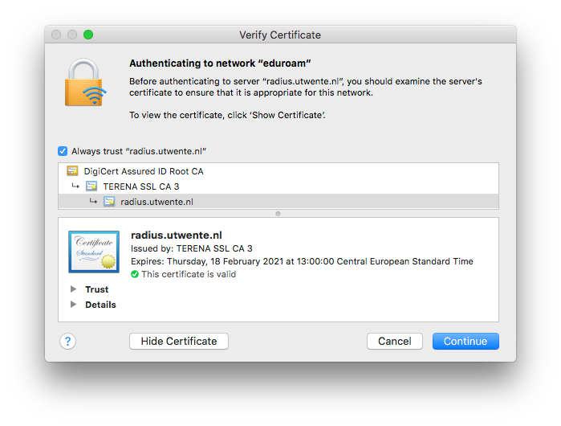

- Check that the certificate is valid and that the server providing the certificate is ‘radius.utwente.nl’.
- Your device may ask to store the certificate in the keychain, use the username and password from your device.

Source: utwente.nl

5.3. EduVPN
Computer (Windows 10):
      - Go to https://ut.eduvpn.nl and log in with your UT account.
      - Click on Windows to download the EduVPN client.
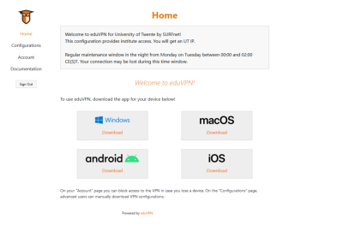
      - Open the installation file and install the software (a restart might be required to finish the installation).
      - Search for EduVPN in the start menu and open it.
      - Select Connect to your Institution.
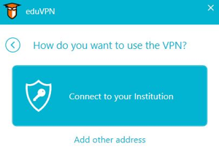

- Scroll down and select University of Twente.
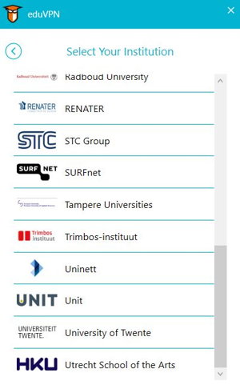
- You will be guided to the login page of the University of Twente, or redirected directly to the page where the application can be approved.
- Click on Approve application.
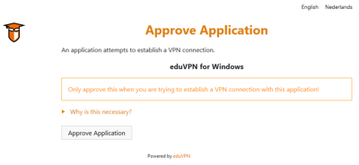
- The profile for institute access is now added to the client.
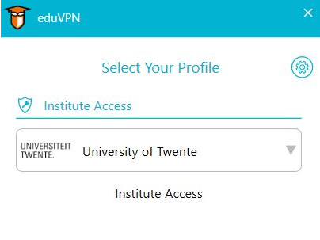
- To connect: select Institute Access and wait until the status icon is green.
- After a (re)start of the pc you only need to open the EduVPN client and select Institute Access to connect.
Source: utwente.nl

5.4. Osiris
To enrol for the first module and all modules after that, Osiris can be used. Osiris can also be used for study counselling, the unenrolment for modules, checking recent study results, an overview of the study progress and checking information about the content of courses.

How to enrol for a module on Osiris?
- Log in at osiris.utwente.nl/student with your student account (username: UT email address).
- Go to ‘Register’.
- Click on ‘Exam component’.
- Select the module you want to enrol for.
- Make sure all boxes are checked.
- At the bottom of the site, click on 'Next' and followed by 'register'.

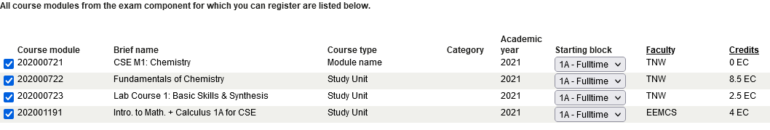

When you have enrolled for the module, you will be automatically enrolled for the Canvas course. With this you will be informed sooner in which project group and/or lab group you are placed. For the enrolment periods visit:
www.utwente.nl/en/education/student-services/education/courses-and-modules/#bachelor-students
You can also see your grades in Osiris. It is important to check if your grades are implemented correctly After every module, because Osiris is the leading grading platform.
For the Osiris student manual please check out this link.

5.5. Osiris Catalogue
In the Osiris Catalogue you can find information on every course that the university offers. You can find it at this link.
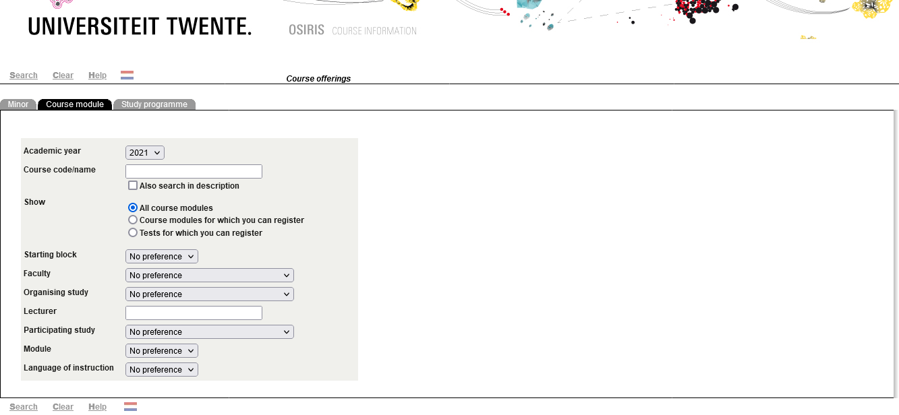

5.6. MyTimetable
To view your timetable of your first module and other coming modules, you can visit the website of the university (rooster.utwente.nl). At the website you can select your own modules and export it to your own calendar (e.g. Google Calendar or Apple Calendar) or PDF. But first you need to login with your student account.

How to add the timetable of the first module?
- When logged in, select ‘+ Add timetable’ in the top right corner of the window.
- Press ‘Module/study programme’ within the section for the academic year 2021/2022.
- A window pops up. Search for ‘Chemical Science and Engineering MOD01 202000721 Fundamentals of Chemistry’ within the first field.
- If you want to connect your timetable to your own calendar, check the box ‘Synchronise these timetables with my connected calendar applications.’
- Click ‘Add timetables’.
- For now, you can continue with clicking on ‘OK’. The setting of the correct student group can be changed, when it is communicated to you during your first days of the academic year.
- Your timetable is added! Close the window.

How to change your student set?
- Select in the right sidebar the three dots.
- Click on ‘Choose student set(s)…’.
- Select your student set ‘CSE MOD01 groep xx’.
- Click ‘Close’.

5.7. Campus app
The ‘Campus app’ is an app where you can view your personal timetable and other scheduled evets. It can give you a route from building to building for the campus terrain. Further, can it show you Points of Interest around the campus. As last does it provide a to-do list for new students, that will help to jump-start your time at the university of Twente. Click one of either link to download the app:

Download on the App Store Get it on Google Play

5.8. Canvas
Canvas is a platform, where you can access course content (e.g. lecture slides, pencasts, etc.), see announcements and messages from teachers, collaborate with your group, view and submit assignments, take online (practice) quizzes and check feedback and (partial) grades. To view the website, visit canvas.utwente.nl and login with your student account (username: student number or UT email address).

The module that you enrolled for, will be listed in the ‘Courses’ page. To view in which group you are placed in, go to the module and select ‘People’ at the left sidebar. At the top of the screen, you can choose between ‘Everyone’ and ‘Groups’, select the second one and view your group. At modules you can view the course content and announcements can be viewed at ‘Announcements’.

5.8.1. Important Canvas Courses

CSE programme canvas course
To search for public courses like the course of the study program CSE, go to the sidebar and click at ‘Courses’. Select ‘All courses’ followed by ‘Browse more courses’. Search at this page for ‘Programme information CSE/ChE’ and join the course with ‘+ Join this course’. At this course you can find useful information about the EER, curriculum, contact details, study tips and FAQ and general announcements of the study program. It can also be joined with the following link.

Canvas Mathematics
Another page which will be necessary for your first module is that of the mathematics module. A separate canvas course needs to be joined for this. Follow the same instructions as the previous paragraph, the exact name of the course will follow in the first lecture/tutorial. It is possible this course is not yet available during the Kick-In, if this is the case try it during the first week of the academic year again.

Canvas about Wellbeing
Canvas has also a course about the wellbeing and mental health of the student. Especially during these times of abnormal events is it necessary to take care of yourself. To enrol for the course, go to the following link.

There is a mobile app available for the Canvas website. For android, go to the ‘Play Store’ and search for ‘Canvas Student’. For Apple, go to the ‘App Store’ and search for ‘Canvas Student’.

5.9. Resource Booker
If you want to book a room, visit the website rb.utwente.nl and login with your student account. A room is available at different places on campus terrain. At this moment, the function ‘BOOK A ROOM’ isn’t available. Three other options are available:

- BOOK A PROJECT ROOM
- STUDY PLACE VRIJHOF LIBRARY
- VRIJHOF LIBRARY PRINTER (MAX 30 MIN)

How to book a printer of study place in the Vrijhof library?
- Click on option 2 or 3.
- Select the wanted time slot.
- To show the availability, select the button ‘SHOW AVAILABILITY’. It will be highlighted in green.
- Click on the calendar where you want to book a place.
- A window pops up. Fill in a title at ‘Booking title’ and select ‘BOOK’.

5.10. Software Manager of NSC
To get the needed programs for the subject, that you will follow during your study, you can download them from the following website: nsc.utwente.nl/software. This website is provided for you, by the Notebook Service Center or in short NSC. Login with your student account (username: student number or UT email address). Down below the programs are listed that are useful for your study time. To install the programs, click on view and follow the instructions on this page.

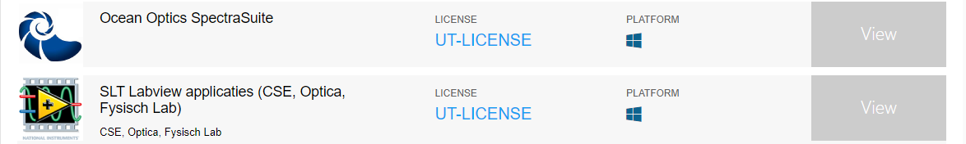

5.10. Lean Library Plug-in
For the projects you will need to search online for articles and books. The university has an on-campus library but bought also a lot of books/articles for online usage. At the university you can access them freely, because you are connected to Eduroam. For off-campus access to this online library, you need the Lean Library Plug-in. This can be downloaded with the following link: www.leanlibrary.com/download.

Source: utwente.nl

6. Online education

6.1. Introduction
Since the start of giving online education, the study programme used a couple of online teaching programs.

6.2. BigBlueButton
This application is built within Canvas. If you go to ‘Conferences’ at the left sidebar, you can join a conference with the button ‘Join’.

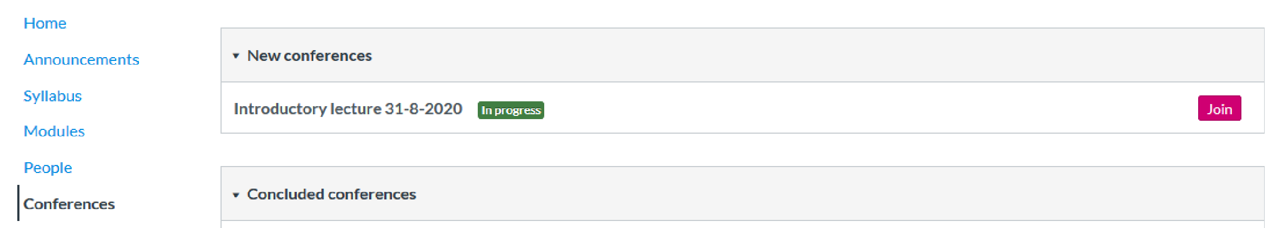

The following screen will appear on screen. At the left sidebar from top to bottom, you can ask questions in the ‘Public Chat’, write notes if you are having a conference with you project group and see all participants of the conference. At entrance of the conference, you will be asked to choose between two options: listening (headphones icon) or speaking (microphone icon). For a lecture pick the first option or the second option if you want to ask questions. For more options, go to the three dots at the right top corner of the screen.

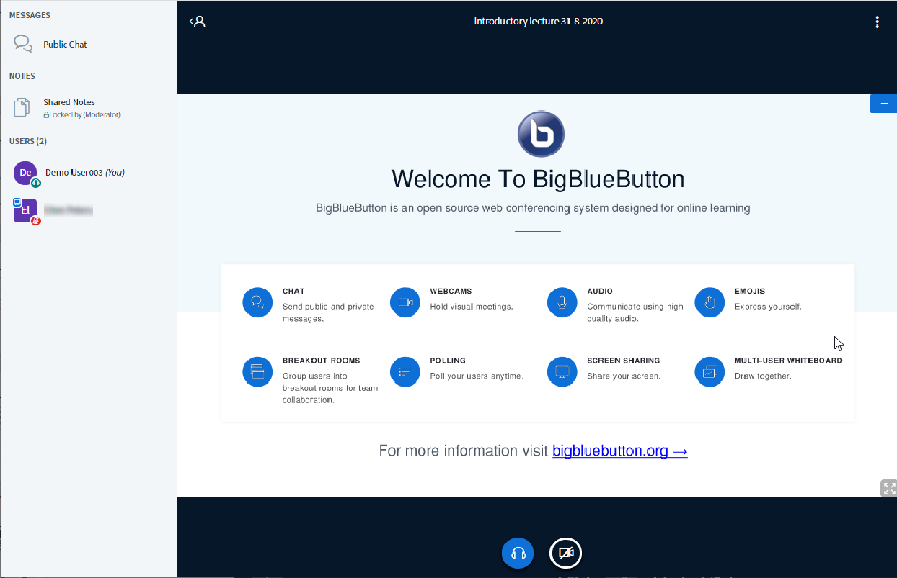

6.3. Other programs
Outside of BigBlueButton, also Microsoft Teams and Zoom are used often. The lecturer will always indicate clearly in which program the tutorial will be held.
For Microsoft Teams you can login with your university account, for zoom you can make an account of your own or login as a guest.

